[System Miami]

DESIGN DOCUMENT

OTHERWORLDLY STUDIOS

Otherworldly Studios

is

Evethalie St. Louis

Layla Hoey

[System Miami]

A Working Title

Design Document

2024

[System Miami]

Contents

1. Introduction
2. Style Guide
3. Mechanics
4. Story
5. UI / UX Documentation
6. Systems Designs
7. Technical Documentation
8. Monetization Strategy
9. Costing Per Feature
10. Production Guide

pg. 1

pg. 2

pg. 13

pg. 15

pg. 20

pg. 22

pg. 29

pg. 30

pg. 31

pg. 32

Introduction

[System Miami] is RPG meets roguelike. The player gets the stats, story and adventure of an RPG with roguelike systems and mechanics. The game is build-your-own adventure, in that the player can basically choose and modify their own difficulty. On each stage, there are three distinct Building types leading to different turn-based combat encounters: Easy, Medium, Hard — each offering a different amount of experience. If the player chooses and completes more Hard encounters than Easy ones, they’ll reach the required Experience Level to pass the stage faster. Our objective is to make a game where the player gets to choose what their character's strengths are and play to those, whether they're best at being sneaky, using magic, or the strongest physically.

Style Guide

|  |  |
| --- | --- |
| 1. Feel 2. Visual References 3. Characters 4. Overworld 5. Rooms | pg. 4  pg. 5  pg. 8  pg. 9  pg. 12 |

Feel

Isolated, Gloomy, Existential

* In spite of the familiar environment.
* Echoes of those gone.
* Following a trail of breadcrumbs towards family / friends.

Sense of a Looming Threat

* Reminiscent of Cosmic Horror (through not a horror game).
* Unknowable entity with a clandestine plan.

Sense of Urgency

* Combat aesthetics
* mostly from non-aesthetic/non-stylistic elements.
* Story, challenge, gameplay loops.

Optimism / Hope

* Outlook is bleak, but there are always reasons to go on.
* Connection with others.
* Limitless freedom within limited circumstances.

A Need To Beat The Odds

* To rescue loved ones.
* Receive and provide hope along the way.

Visual References

*Hades* - Supergiant Games

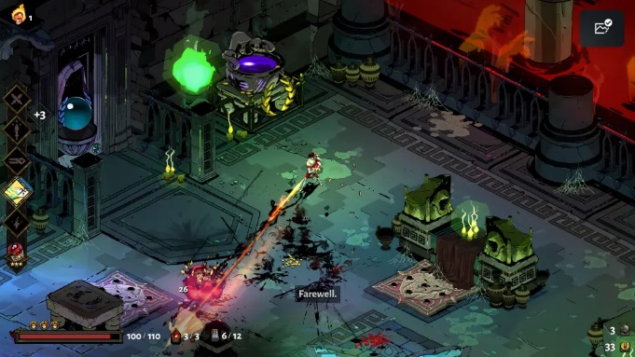 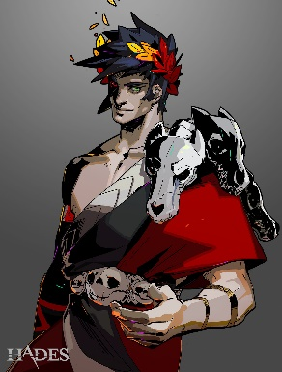 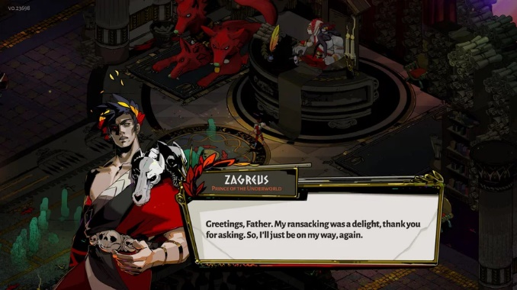 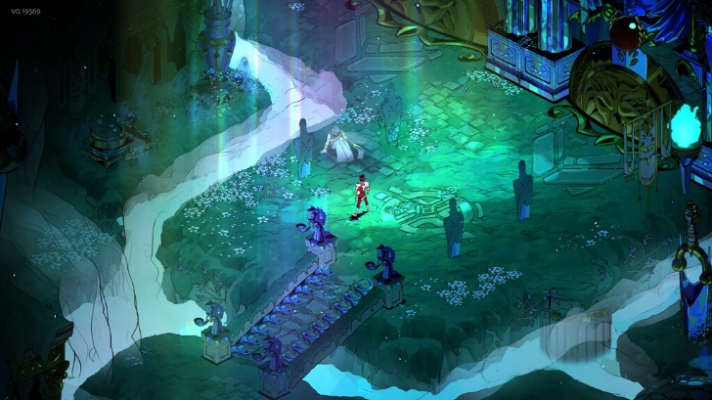

*Kipo and the Age of WonderBeasts* - Dreamworks

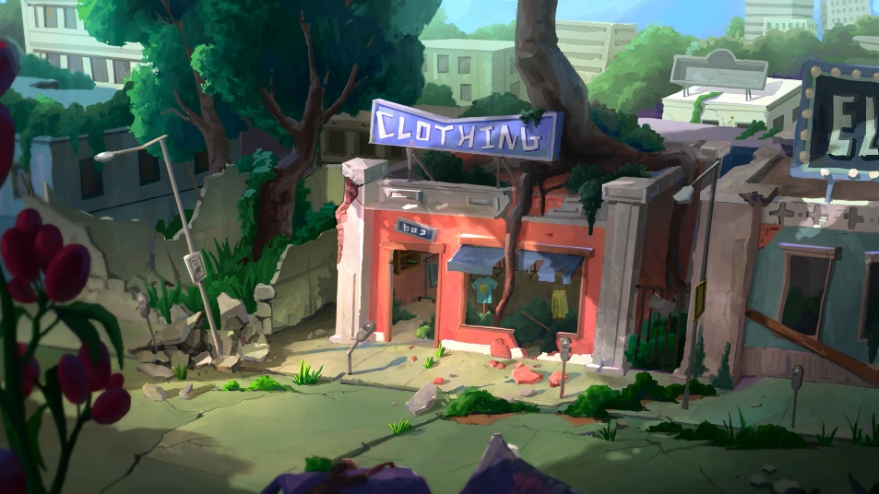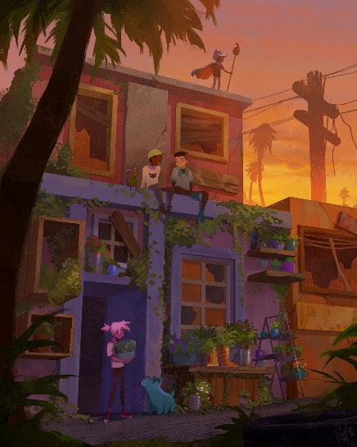

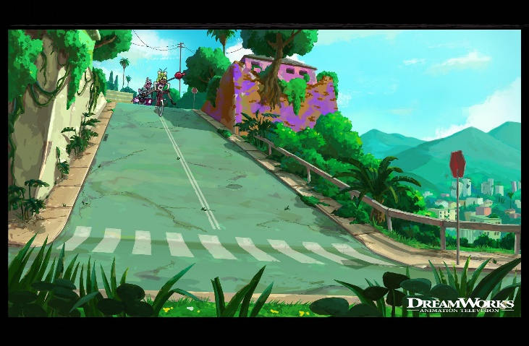

Visual References

*Into The Breach* - Subset Games

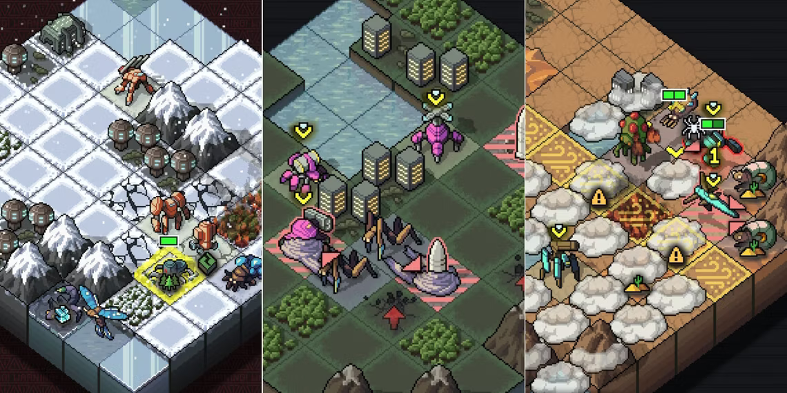

*Disco Elysium* – ZA/UM

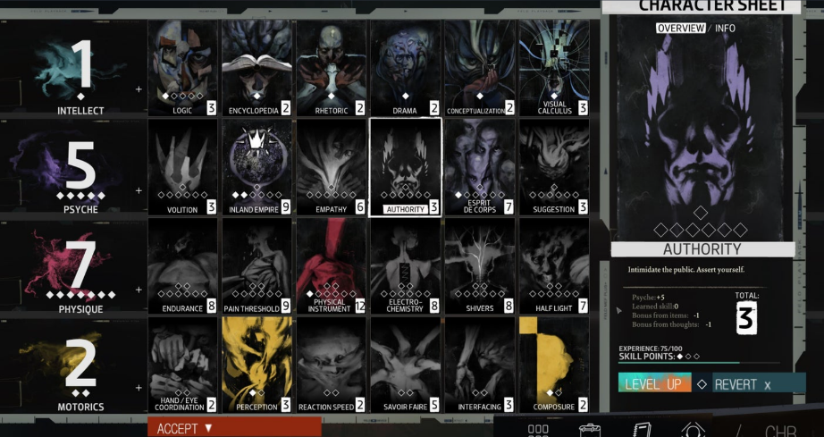

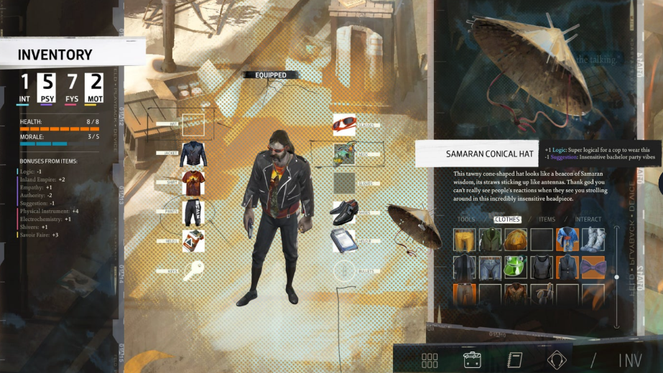

Visual References (Photos of Miami by Layla Hoey)

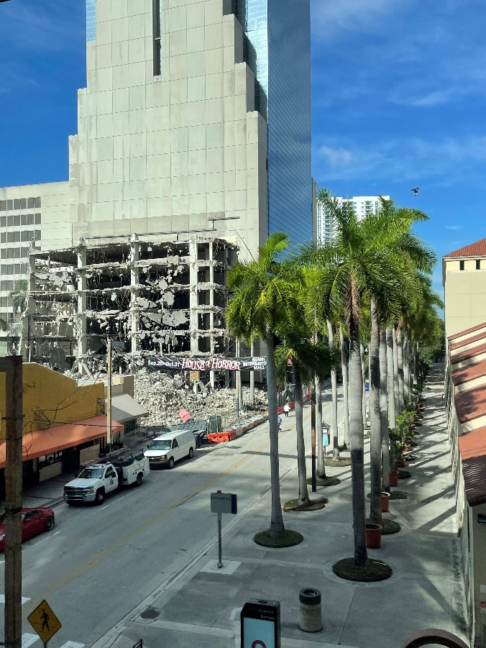 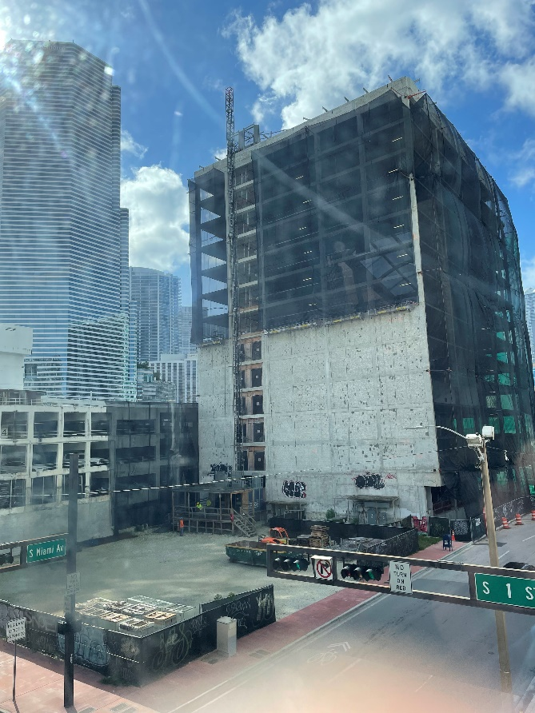

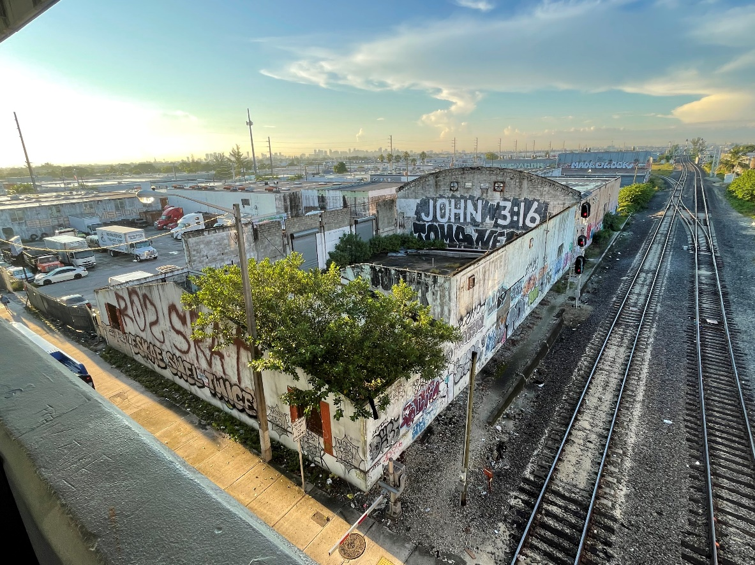

Characters

2.5D Option

* 3D character model
* Walk cycle
* Few animations (surprise, determination, defeat)

2D Option

* Pixel art sprites
* 8-Directional movement
* Few expressions (surprise, determination, defeat)

Classes:

|  |  |
| --- | --- |
| Fighter | Tank |
| Mage | Rogue |

Overworld

Stages

* “Area” / “Zone”

Intersections

* Number per Area scales up depending on the number of Rooms the player must complete to advance.

Buildings

* Vary in height and color.
* Some are interactive, some not.

Alleyways (Shops)

* Spawn randomly between buildings (0 or 1 per Area).

Vehicles

* Visual aesthetic only, spawn infrequently but there are >1 per Zone.

Level Design

* Areas are **procedurally generated** at runtime within set parameters.
* Grid/tile system.

Sparse animations

* Mostly UI
* Rarely NPCs
* Fauna

Omnipresent flora, mossy growth, and detritus

Overworld — Concept Art (from prototype)

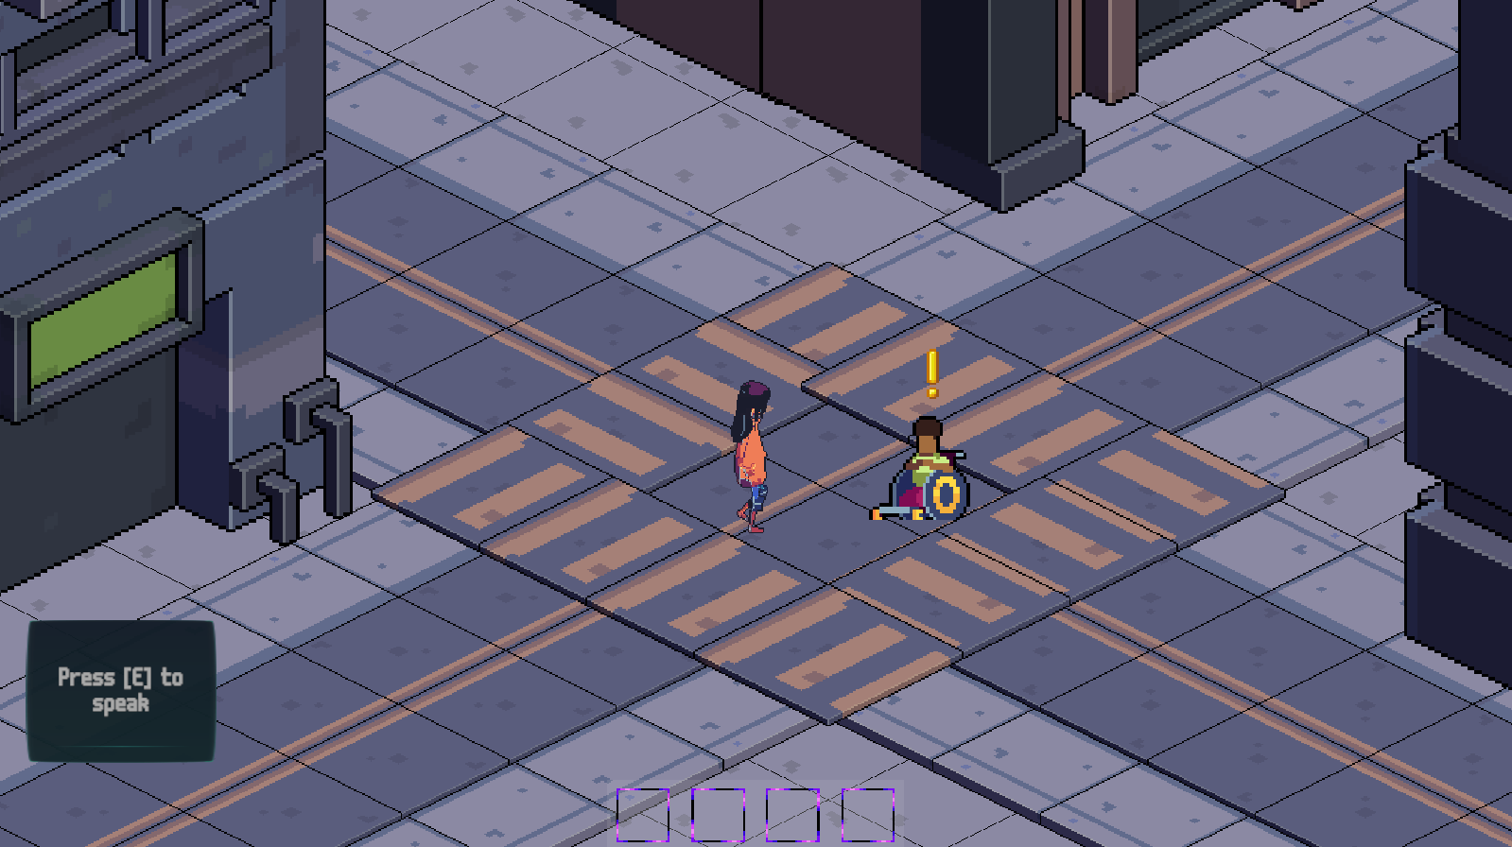

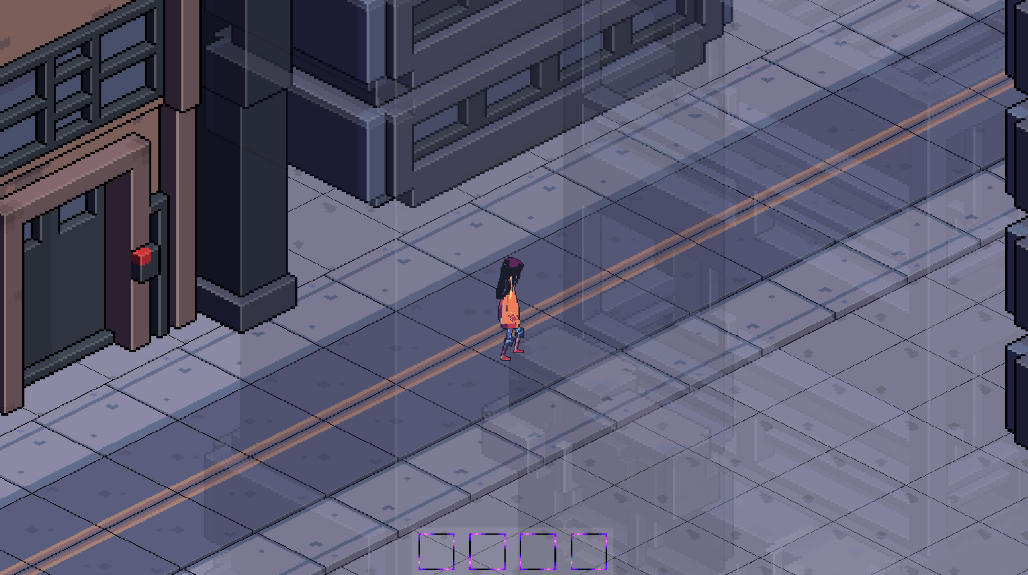

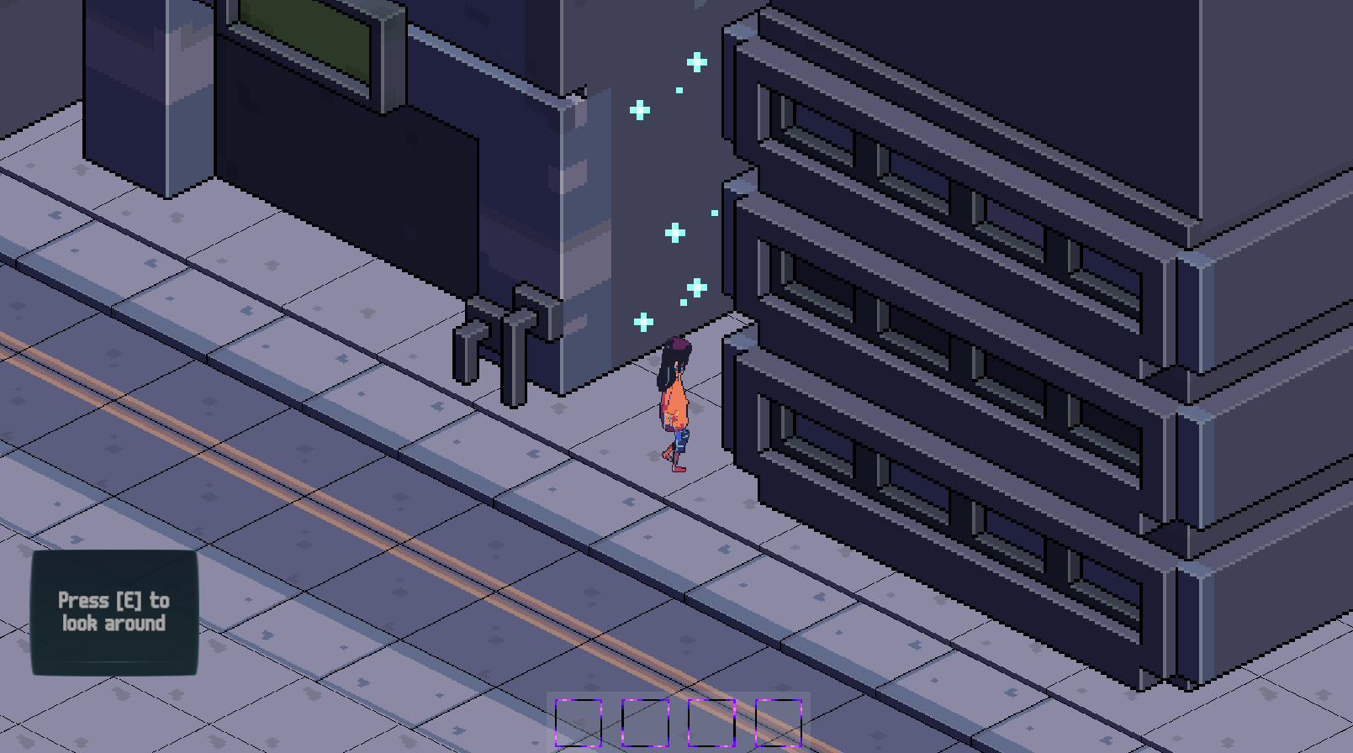

Overworld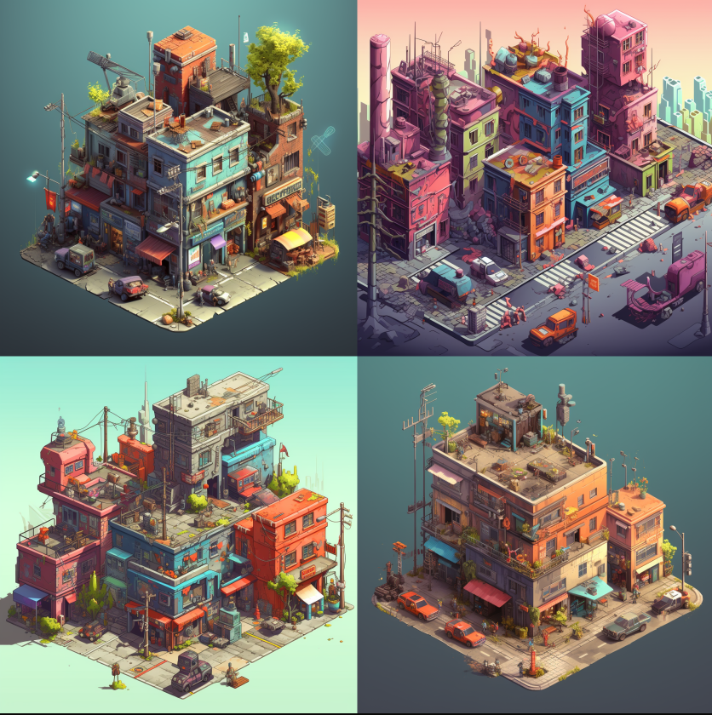 — Concept Art (Generated by midjourney)

Rooms

Combat Encounter (Building)

* Isometric game board (slightly raised from background)
* Stylistically will consist of different tilesets depending on the room/environment type, but all will serve the same functions
  + Normal
  + Hole
  + Raised block
  + Obstruction (cracked floor, detritus)
* Painted-style **static** backgrounds (very limited animations in background, if any)
* 4-8 backgrounds / room types

Shops (Alleyway / Ship)

* Alleyways or Alien ships
* First-person view
* Drawn still image of “shopkeep” (whoever this may be)
* Painted-style **static** backgrounds (limited animations in background, if any)
  + Dumpster, trash, campfires, street-art
* Animation in shops will likely be UI exclusive
* 4-8 backgrounds / room types

Empty (Building)

* Same layout as combat rooms
* Only contain a reward
  + Resources / Loot
  + Story progression

Rooms — Concept Art (from prototype)

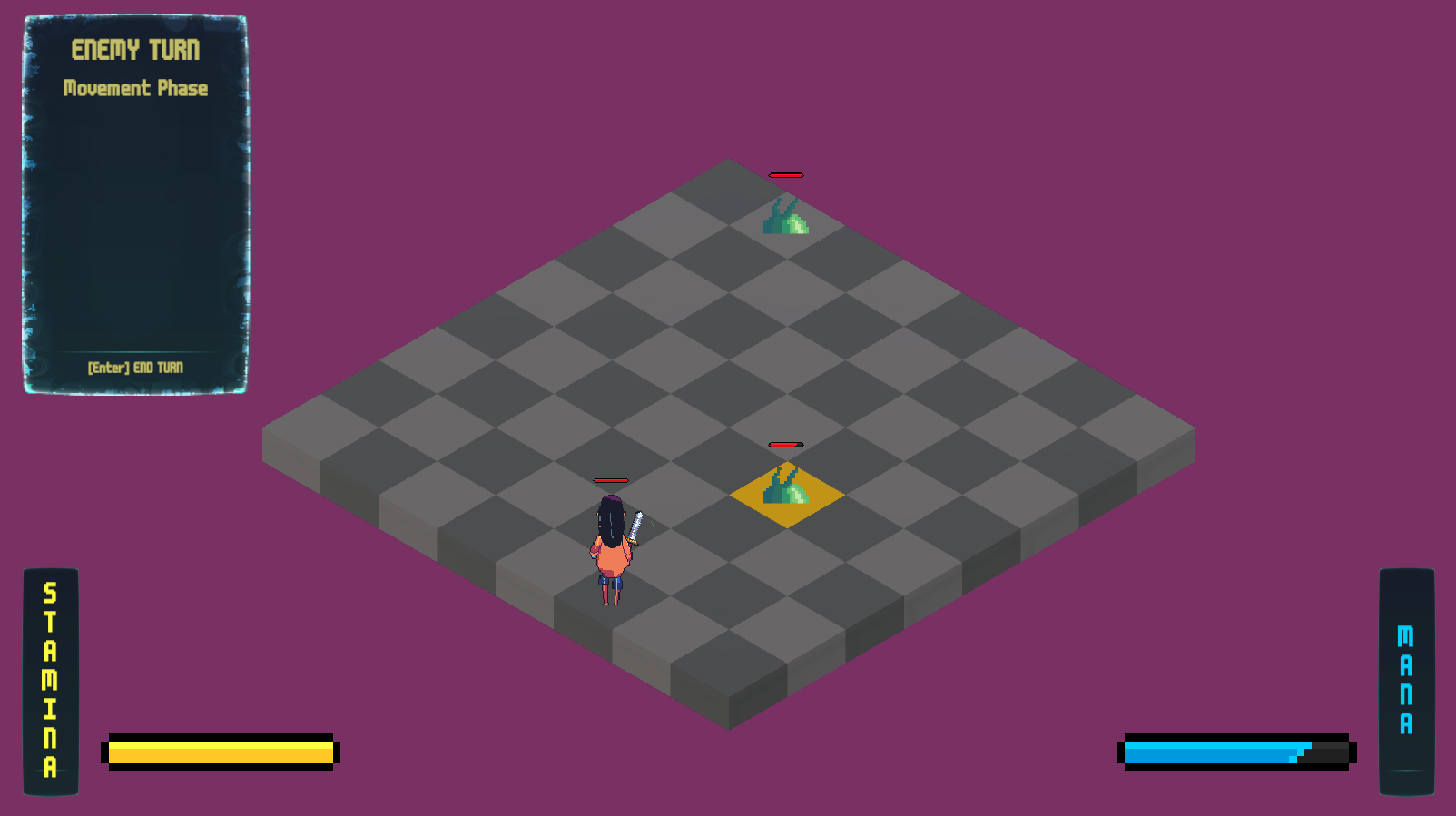

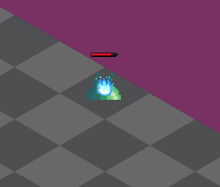

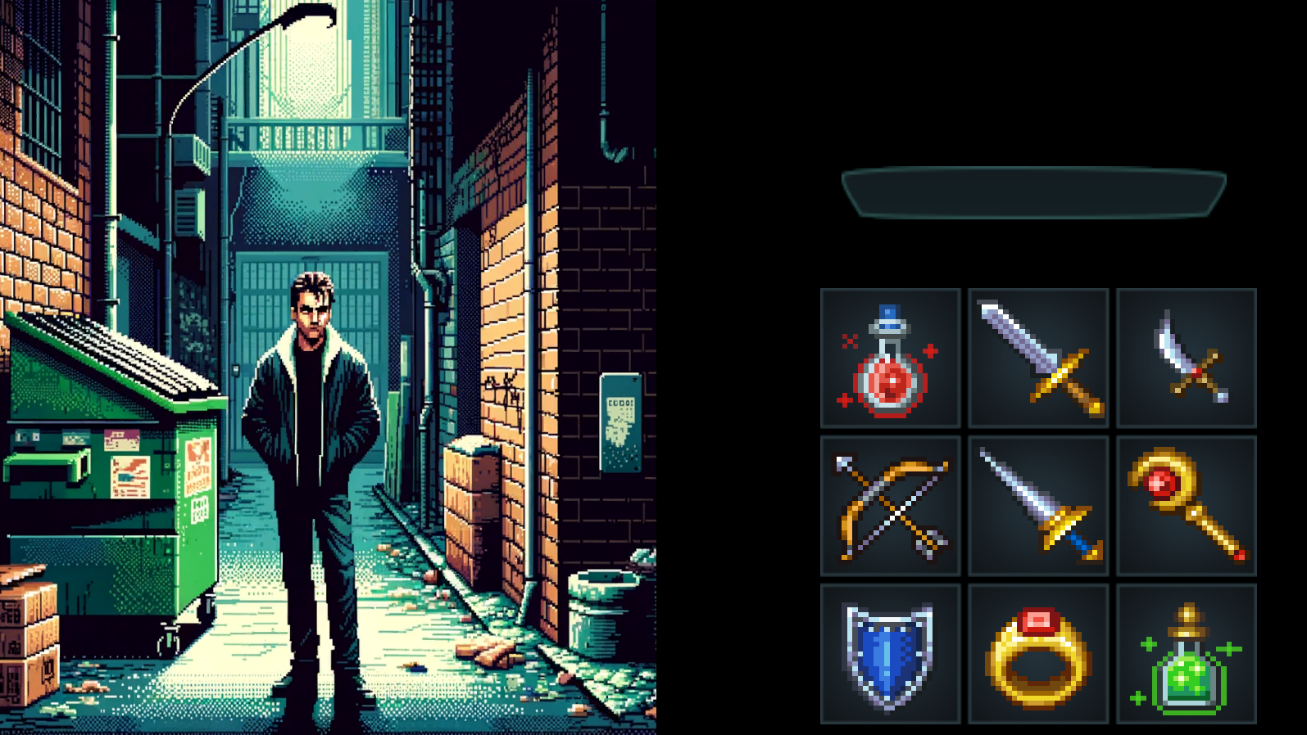

Mechanics

Rules

Progression

* Each Area has an Experience Level threshold that increments by five. (To move from Area 1 to Area 2, the player must have reached Experience Level 5)
* To level-up, a player must gain a certain amount of experience, obtained by completing combat encounters.
* When a player levels up, they are awarded two attribute points to upgrade any two attributes, which determine their stats (attack, defense, etc.).

Combat

* Player takes any 2 of 4 available actions per turn.
  + Move – move a certain number of spaces (as determined by stats) on the game board.
  + Use Item – use an Item from Inventory that will grant a benefit.
  + Use Ability – use a Physical attack, defense, or maneuver.
  + Cast Spell – use a Magical attack, defense, or maneuver.
  + **Defeat all enemies in the room to successfully complete the encounter.**
  + **Loss in combat rewinds progression back to entry to the Area (NOT the encounter).**

Player Goals

Progress through all areas

* Gain Exp and currency by visiting new Buildings to complete combat encounters.
* Check Alleyways for makeshift shops set up by Resistance fighters to gain new Abilities and learn new Spells.

Finish the main story quest

* Save your sister from the Aliens.
* Reunite with your family.

Emergent Gameplay

Combat

* The outcome and playstyle of each encounter will be influenced by, or determined by, the player’s character build.
  + Character Class
  + Character Stats
  + Abilities and Spells
* Enemies can be defeated in more than one way.
  + Offensive tactics
  + Defensive Tactics
  + Outsmarting AI
* As the player gains Abilities, Spells, and Items, they will find new use combinations that produce unexpected results.

Progression

* Player cannot move on to the next Area without reaching a certain Experience Level.
* Player must strategize to determine what Buildings to explore in order to most efficiently reach the threshold.

Difficulty

* Freedom to choose what combination of Easy, Medium, and Hard encounters to combine to reach their goal.
* Players may find themselves backed into a corner by their previous decisions here, creating a learning experience that will aid them on their next attempt.

Story

Interest Curve

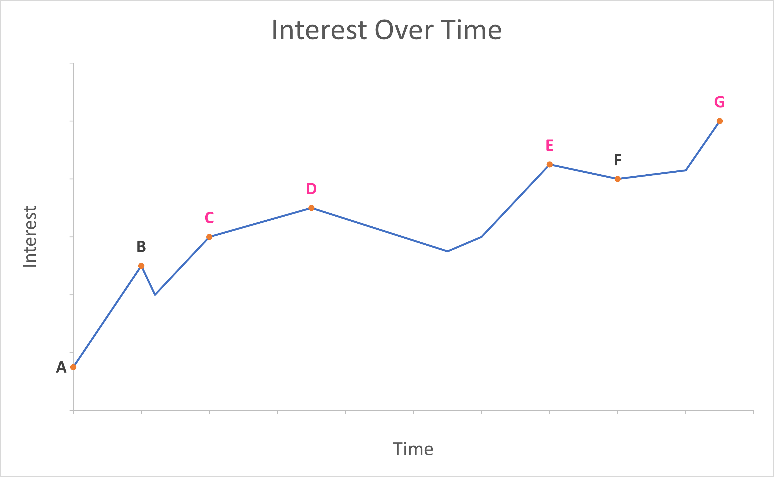

Main Story Points

1. Players are thrown into the story. The narrative centers around familiar Miami, and the charming/simple goal of picking up their sister from school, until an unexpected apocalyptic event.  Players experience Character Creation, immediately immersing them in the game's world and introducing them to the Stat System.
2. Player leaves the house and meets an NPC who does some narrative worldbuilding, and ushers them to the 1st battle, a combat tutorial, introducing core mechanics.  They will then have the option of completing additional encounters before entering the school.  Players are taught about acquiring and using items, thereby solidifying the core gameplay loop.
3. Player enters the school, which is overrun with monsters, and encounter an extremely powerful Boss who has taken their sister captive.  They cannot defeat it, instilling a drive to return later, after becoming as powerful as possible. Player is sent to a makeshift hospital by an NPC who will now serve as a guide.
4. The apocalypse is now a sort of SNAFU (Situation Normal: All Fucked Up). Players experience their first post-tutorial stage, encountering new enemies and gaining new abilities. There are new types of encounters, such as “dungeon breaks” and NPC rooms containing loot or story progression. Each stage will be built using one of 3-5 cohesive asset packages, creating aesthetic variation. *Randomized* placement of *randomized* obstacles/enemies within encounters --and *randomized* placement of said encounters within each stage-- will result in new challenges and opportunities for emergent strategy, ensuring engagement through the gameplay loop.
5. By now, the player is heavily invested in the outcome, having probably died multiple times, leveled-up, and developed strategies for their character build. Now, they finally get their rematch. The game is balanced so the player feels responsible for whatever the outcome.  Upon losing, they’ll feel their defeat was preventable, whereas upon success, they’ll feel they could have failed, had they done *anything* differently. They’ll either be proud --or **want**to be proud-- of their play.  Defeat will motivate another attempt right away, while victory will sustain interest through the outro, ready to achieve this feat with another loadout/build.
6. The player has saved their family, securing a spot in a so-called “Andromeda Utopia.”  Results of the run are displayed, and the story *seems* to resolve; all is well, and the family is preparing for their journey.
7. Brief finale of the family boarding whatever vessel is to take them to their new reality.  The protagonist is uneasy, noticing some red flags, wondering if this may not be a ‘utopia’ in the sense they were promised. Players’ interest will be at a peak here, from victory and an ominous narrative ending, and the game is designed to accommodate this; players can start another run with one click.

Story Slice (Game Start through Tutorial)

The player wakes up [Black screen Fade]. The game starts with the player standing by the side of the bed there is a ding sound with a visual notification on the players phone.

The game prompts the player to walk to the dresser. [Use W, A, S, D to move]. As the player reaches the phone [Press E to interact] They see a text from Mom.

{“Hey Sweetie, going out of town for a getaway with your dad, please pick up your sister from school”} [Press X to exit].

The player is prompted to put the phone in their inventory [Press G to place item in inventory] The player is prompted with arrows to go to the bathroom. The screen switches to the player character in the mirror [What is your Name]. As name selection finishes a screen suddenly pops up onto the mirror.

{ “Congratulations Planet A6544, previously known as Earth. You have been selected to join the Andromeda System” Please select your starting class. This will also determine your starting stats. **Fighter**, Bonus to Strength, Detriment to Wisdom and Intelligence. **Mage**: Bonus to Intelligence, Detriment to Strength and Constitution. **Tank**: Bonus to Constitution, Detriment to Dexterity and Intelligence. **Rogue**: Bonus to Dexterity Detriment to Strength and Constitution.}

After the player chooses a class there is a ringing sound. [Press I to access your inventory] [Press Q to place item in quick slot menu] [press 1 to use item in slot 1 of quick slot menu].

“Sweetie are you ok? Did you see the screen? For some reason your father and I got different screens, something about him being a non-combat class? Anyways we’re stuck on the highway leading out of the city. We won’t be able to get to your sister in time. You need to go to the school and save her! Be careful inside the buildings there are some horrible monsters i-“

The phone hangs up abruptly. [New quest acquired! Save your sister!] An arrow leads you out of the bathroom and to the front door. [Doors with an exclamation mark signify doors that will advance your current quest]

The player leaves their house to get to a street. On the street there are 3 doors. In front of the door closest to them there is a man in a wheelchair with a question mark above his head. Once the player walks to the NPC there is a small prompt on the top [a question mark signifies a side quest].

“Thank god! Please help me! My daughter is trapped in this building please help her! I promise I will make it worth your while, I got an alchemist noncombat class”

[Player Options: “Why don’t you do it?”, “Ok”] [Why don’t you do it]

“ I would but without the use of my legs and a noncombat class I would pretty much just be monster bait” [Player Option: “Ok”] “Thank you so much!”

The player walks up to the door [ Door colors correspond to the difficulty of the door. Red is a hard door. Yellow is a medium door. Green is an Easy door] The player walks into the door to 3 monsters.

The combat tutorial ensues. [These are your skills, spells, and consumables select a skill and a target to use them, Skills cost stamina, Spells cost mana. At level one you have 4 moves. Level up to acquire more!]. The player fights the monsters. At the back of the room there is a little girl. Once the player walks into the range of the little girl.

“Thank you so much for saving me Mister! Ooh what is that its so shiny!”

A golden chest has appeared behind the little girl. The player is then awarded with their starting class weapons. (Big shield, swords , and heavy armor for Tanks, Swords and light armor for Fighter, Daggers, Bow and arow, and leather armor for Rogues, Staff and robes for mages. The player then walks out of the door with the little girl. The screen switches to the little girl next to her dad.

“Thank you so much! I told you I would make it worth your while. While I was playing around with my non combat skills I managed to make this”

The player is rewarded with a weak health potion. The player then has the option of going to the other building or straight to the school which has a black door with a golden exclamation mark on it. When the player goes to the black door. They are greeted with a giant spider and their sister trapped inside her web.

“[Player Name] you’re here! Run or else she’s going to eat you!”

The player starts to fight the monster with the sister healing whenever the player’s health gets too low. The monster cannot be defeated. The 3rd time the player health gets too low the screen fades to black with a voice saying

“It’s ok I got you”

Our main character then wakes up in a makeshift hospital room. The voice he last heard before passing out speaks

“You’re awake! I don’t know what that monster did to you to you but it sure did do a toll, How you doing champ?”

The main character wakes up confused and asks

“How did I get here?” He jolts up “My sister!”

The stranger calms him down “

It’s Ok she’s alright, more than alright now, One of the strongest healers we got”

The main character is confused and stays silent. The stranger sighs.

“I guess that doesn’t mean anything to you huh?” He explains how its been 2 years and the world has calmed down. There are still dungeons but now a special job force called hunters have been tasked with taking care of them. “I’ll get you to your sister and the rest of your family too, but we got to get you leveled up a little first or you wont make it to them in one piece”.

At the end of the 1st stage he gets a system prompt “Congratulations on surviving this long, all humans who are below level 10 in 1 month will be culled, Any human level 10 and above will get to formally join the Andromeda Utopia.”

UI / UX Documentation

Pause Screen

Character Viewer

* Walking animation
* Rotatable

Menu Tabs

* Inventory
* Map
* Stats
* Settings
  + Standard A/V settings options
  + Accessibility (Color settings, subtitles, font, animation settings, etc.)

Combat

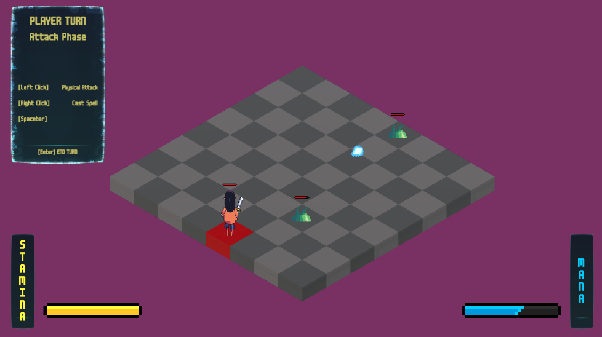Turns

* Player turn or enemy turn
* Turn phase (movement, attack)

Player State

* Health, Stamina, Mana
* Attack, Magic, Item slots

Controls

* Dynamic Panel with controls on screen at all times (**collapsable**)

Overworld

Constant Information On Screen:

* Health
* Stamina
* Mana
* Experience Level
* Experience Points
* Quickslot Inventory

Variable Elements On Screen:

* Input / Interaction Prompts
* (?) and (!) to signify objectives.

Symbols/Colors on Building doors signify difficulty level

* Green = Easy
* Yellow = Medium
* Red = Hard

Systems Designs

|  |  |
| --- | --- |
| 1. Procedural Generation  2. Classes  3. Stats System  4. Turn-Based Combat  5. NPC — Enemy  6. NPC — Non-Enemy  7. Quest System  8. Inventory System  9. Level & Map Unlocking | pg. 24  pg. 25  pg. 26  pg. 28  pg. 29  pg. 29  pg. 29  pg. 29  pg. 29 |

Procedural Generation

Areas

* Generation depends on the player’s progression.
* Number of encounters, and therefore intersections, increase as the player levels up and advances.
* Either 0 or 1 Shop per Area.
* Environment is generated within the scope of a theme for the Area.

Combat Encounters

* Each Combat Encounter is procedurally generated at the time of commencing the interaction.
* Number of enemies is determined in a range by current progression in the game.
* As is their difficulty.
* Rewards are also randomly generated (some are dependent on Character Class).
* Tileset of Game Board, and the background image of the scene, is dependent on the current Area’s biome / environment.

Classes

Four classes

* Fighter
* Tank
* Mage
* Rogue

Classes determine :

* Starting stats
* Gear rewards from completion of encounters
* What skills / spells one is allowed to acquire / buy
* Character appearance throughout

Character Creation

Power of player choice

* Player creates content
* Player chooses gender (Male, Female, Non Binary)
* Basic character creator
  + Set / modify the appearance of the player character.
  + Hair
  + Clothing
  + Accessories

Stats System

Stats determine how a player must approach combat, and will serve as an entry point for creating player interest.

There are 5 Attributes which determine the stats of the player in combat.

* STRENGTH
  + Physical Attack / Skill Power
  + Skill Slots
* CONSTITUTION
  + Health
  + Armor (Damage Mitigation)
* DEXTERITY
  + Stamina (Resource for Skills)
* INTELLIGENCE
  + Mana (Resource for Spells)
* WISDOM
  + Magic Attack / Spell Power
  + Spell Slots

Formulas:

|  |  |  |  |
| --- | --- | --- | --- |
| STRENGTH | formula | WISDOM | formula |
| Attack Power  (Base Effect 2.5) | (Strength * 1.5) + Base Effect | Magic Power  (Base Effect 2.5) | (Wisdom * 1.5) + Base Effect |
| Skill  Slots  (1 Min  6 Max) | If(Strength >= 5)  1 + (Strength – 5) /4 | Spell Slots  (1 Min  6 Max) | If(Wisdom >= 5)  1 + (Wisdom – 5) /4 |

|  |  |  |  |
| --- | --- | --- | --- |
| DEXTERITY | formula | INTELLIGENCE | formula |
| Stamina | Dexterity * 2 | Mana | Intelligence * 2 |

|  |  |
| --- | --- |
| CONSTITUTION | formula |
| Health | If (Constitution < 10)  Constitution * 5  If (Constitution >= 10)  (Constitution * 5) + 50 |
| Defense (Damage reduction per-hit) | Constitution |

Turn-Based Combat

Tiled Game Board

Turns move from Player to each Enemy

Each turn has Phases

* Movement Phase
* Attack Phase
* Players can use non-Phase-specific items at any time during their turn

Player takes any 2 of 4 actions during a turn

* Move
* Use Ability
* Cast Spell
* Use Item

Actions use resources

* Tile movement costs Speed (a number of tiles determined by Experience Level)
* Skills – such as physical attacks – cost Stamina
* Spells cost Mana

Player brings limited actions into each encounter

* Limited Skill slots
* Limited Spell slots
* Limited Item Slots

NPC — Enemy

Enemies will run on a very basic AI getting more complicated as the player gets stronger.

Not overly-robust

NPC — Non-Enemy

No AI

Simple Dialogue (Occasional tree)

Quest

Rigid questline with limited choices

Players will be given quests that they can complete in dungeons for various rewards.

Inventory

A system will be programmed to track what players have in their possession.

* Skills
* Spells
* Items

Map unlocking

New Areas unlocked as the player progresses

Can only access the map for the current Area

Technical Documentation

Release Platform — PC (Steam)

Our game platform will be PC with possibility for console later on. The game engine would have to be able to handle 2D and 3D graphics and have scriptable movement and behaviors. Game engines that would be best to develop this product are Unity, Godot, and Unreal Engine.

Graphics

The game itself would not have demanding graphics, leaning towards a hand drawn style. The game should be able to run on a mid-end PC.

Design Complexity

A lot of moving parts with numerous inter-dependencies.

Additional Research

Research will need to be done on the layout and buildings in the city of Miami.

Further research will be required on procedural generation and how to incorporate that into multiple game systems.

Monetization Strategy

Paid Game — No Ads

Target Price: $20

Standard price for an indie game of its size.

This price targets the RPG and roguelike fan community, with standard RPGs costs ranging from around $20 up to $70 on the higher end of the price range.

Additional Content

Bundle Purchase — $2 - $5 additional

* Soundtrack
* BTS content
  + Sketches
  + Concept Art
  + Storyboards

DLC / Expansions — $5 – $10

Costing Per Feature

Proposed Engine: Unity

Unity Pro License Cost

$2040/year per seat. Estimating 8 members using: **$16,320**

Personnel

Three programmers

Five artists

One sound designer

Two UI/UX designers

Timeline

We expect development of this game to take about 6 months.

8 hour work day

Programmers & UI/UX Designers — **$129,990** (for 5 people over 6 months)

* + $25 / hour
  + $4,333/month, $52,000/ year

Artists & Sound Designers — **$124,920** (for 6 people over 6 months)

* + $20 / hour
  + $3,470/month, $41,600/year

Two developers, two artists and one UI/UX designer will be kept for a time after release for bug fixing and expansion.

Production Guide

Estimated guide using:

* + Start Date in mid-late August 2024
  + Release Date March 1, 2025

Estimated Total Cost - **$331,047**

* + $271,230 over production
  + 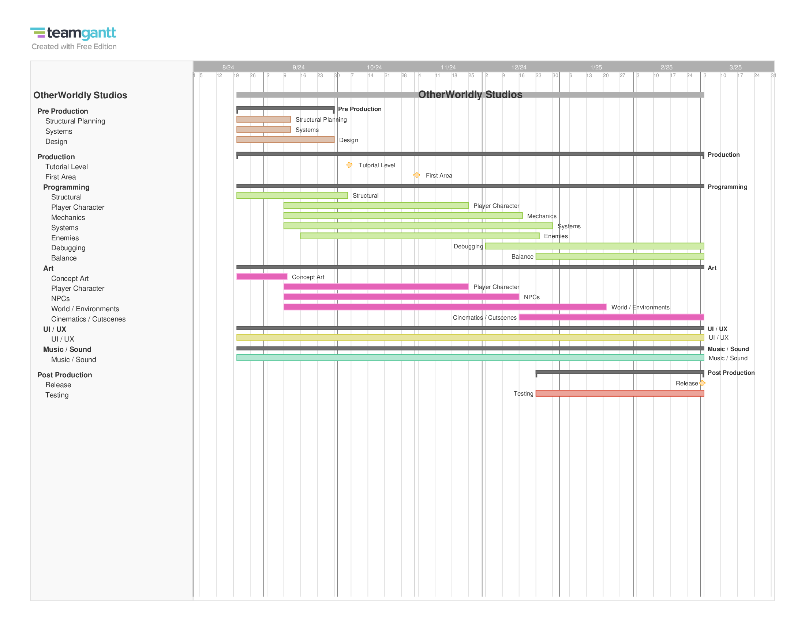$59,817 over post-release (3 months)